# How to stake coins

In this guide we will explain how to stake our DECENOMY coins.

First of all let's open our wallet (in our case TRTT)

In order for staking to be active, our coins must have at least 600 confirmations (about 10 hours).

A second requirement is that the wallet is unlocked.

To do this we can click on the padlock icon at the top right.

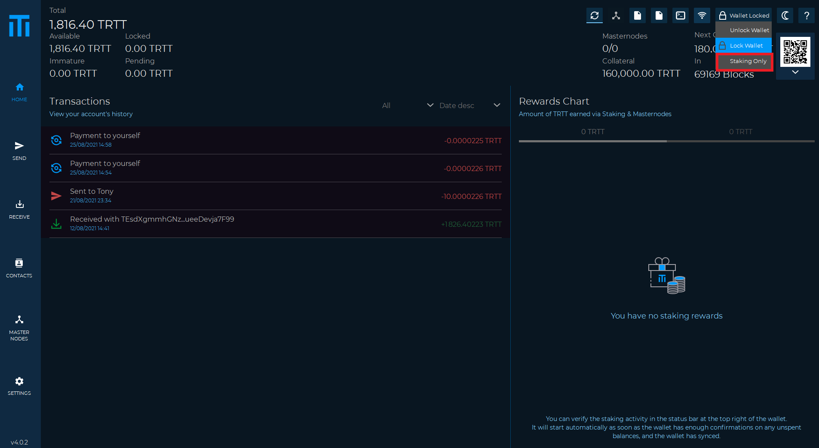

Once this is done, the staking icon will activate.

To be able to stake, the wallet must always remain open.

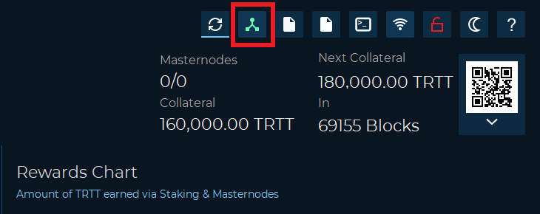

In case staking is not activated, we can use the “getstakingstatus” command in the debug console, to see more details on the causes of the problem.